Preparation of Papers for Applications of Modelling and Simulation (AMS)
First A. Author^{1*}, Second B. Author¹ and Third C. Author²
¹Faculty of Electrical Engineering, Universiti Teknologi Malaysia, 81310 UTM Johor Bahru, Johor, Malaysia
²Department of Automatic Control and Systems Engineering, The University of Sheffield, Sheffield, UK
*Corresponding author: author@fke.utm.my

Copyright © 2024 The Authors.
Abstract: These instructions give you guidelines for preparing papers for APPLICATIONS OF MODELLING AND SIMULATION journal. This document is in Microsoft Word.
Keywords: Insert five keywords separated by a semicolon.

1. INTRODUCTION
This document is a template for Microsoft Word. Structure the paper into sections and subsections, including the opening brief abstract, introduction, body and summary. Include a list of references at the end of the chapter.

2. FORMATTING

Paper Size, Margins and Font
The page is set to paper size A4 $210×279$ mm in portrait orientation. Margins set to 17.8 mm for top and bottom whereas 16.5 mm for left and right sides. Header/footer set at 7.6 mm.
The manuscript is typed in “Times New Roman” font in “Regular” style and size 10 pt, except for headings and titles, which are set to different sizes.

Paragraphs
All paragraphs should be justified left and right. The first paragraph of a section begins flush left as this, and is referred to as “body justified” in the style drop-down menu.
Indent the first line of second and subsequent paragraphs of a section.

Equations, Symbols and Units

2.3.1 Equations
Use the Microsoft Equation Editor for equations in your paper.
All equations must be typed on a single line and numbered. The equation is centred and the number at the end of the line as

$y\left(t\right)=\frac{Aω}{\sqrt{1-ζ^{2}}}e^{-ζωt}sin⁡(ω\sqrt{1-ζ^{\text{2}}}\left(t-t_{0}\right))$ (1)

When referring to equations use the style “Equation (1)”. All symbols must be defined.

2.3.2 Units
Use only SI units throughout the paper.

Figures and Tables
Generate diagrams in black and white with sharp black lines. Make sure the diagrams float with the text and that text does not flow underneath the diagram.
Place caption for figures at the bottom and caption for table at the top, and as close as possible after first citation. If your figure has two parts, include the labels “(a)” and “(b)” as part of the artwork. Separate columns and rows of tables with solid lines.
Symbols, notations, abbreviations appearing in figures and tables should be consistent in style, font type with the text and equations. The style of citation to figures and tables should be as “Figure 1” and “Table 1”. Follow the styles given below.

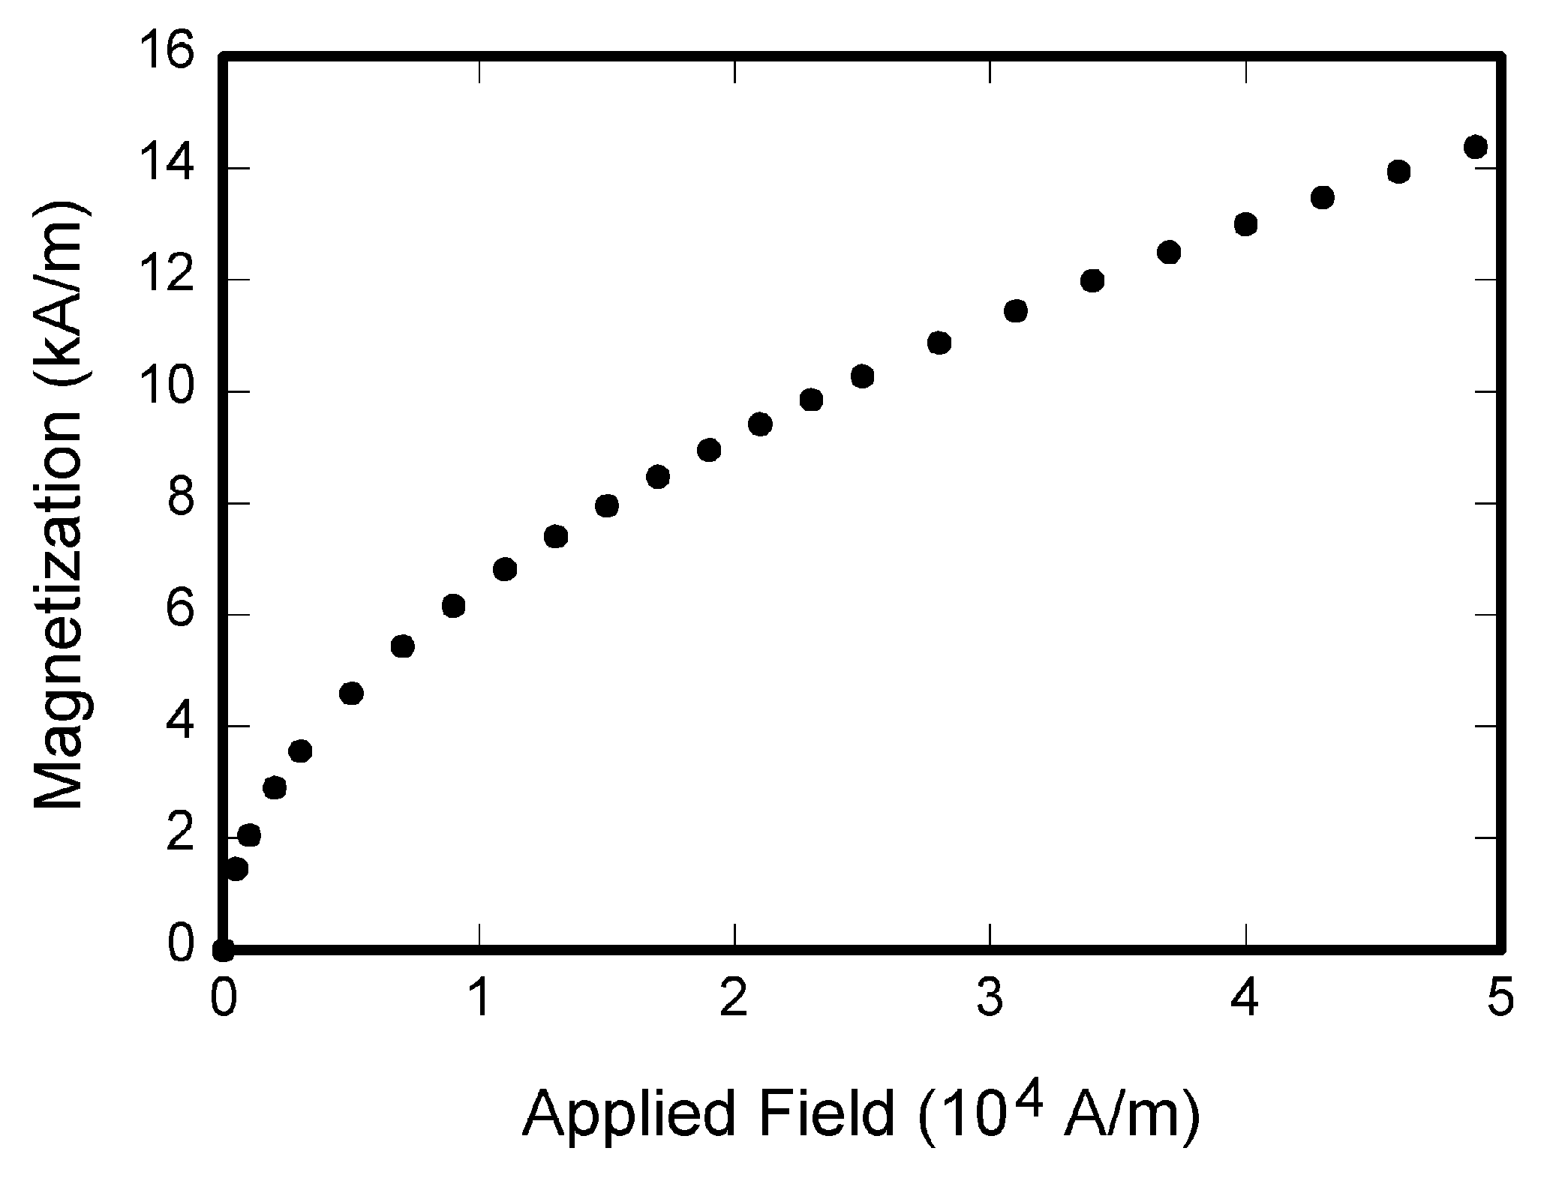
Figure 1. Figure caption, centre.
Table 1. Table caption, centre.
Column title 1 | Column title 2 | Column title 3

References
Number citations consecutively in square brackets. Please note that the references at the end of this document are in the preferred reference style. Give all authors’ names; Use a space after authors' initials. Do not abbreviate journal and conference titles. References [1], [2], [3], [4], [5] and [6] are the style for a book, book chapter, journal article, conference paper, thesis and website respectively.

3. CONCLUSION
Although a conclusion may review the main points of the paper, do not replicate the abstract as the conclusion. A conclusion might elaborate on the importance of the work or suggest applications and extensions.

ACKNOWLEDGMENT AND FUNDING
Use the singular heading even if you have many acknowledgments. State any funding involve.

REFERENCES
- N. S. Nise, Control Systems Engineering, Hoboken, New Jersey: Wiley, 2019.
- K. Fang and J. Huo, A model validation method based on convolutional neural network, In Methods and Applications for Modelling and Simulation of Complex Systems, Singapore: Springer, 1911, 2024, 194-203.
- S. Chen, B. Mulgrew and P. M. Grant, A clustering technique for digital communications channel equalization using radial basis function networks, IEEE Transactions on Neural Networks, 4, 1993, 570-578.
- S. P. Bingulac, On the compatibility of adaptive controllers, Proceedings of 4th Annual Allerton Conference on Circuits and Systems Theory, New York, 1994, 8-16.
- J. Williams, Narrow-band Analyzer, Ph.D. Dissertation, Harvard University, Cambridge, USA, 1993.
- Magnetek Material Handling, Crane anti sway control system. https://www.magnetekmh.com/Material, 2016 (accessed 01.12.2016).

APPENDIX
Appendixes, if needed, appear after the references.

