Ligand-Based Pharmacophore Modelling Targeting α-synuclein Misfolding For An Effective Treatment Of Parkinson’s Disease
Supplementary file
SI-1: Validation for docking scores using set of Decoy sets
S/NO | DECOYS SETS | DOCKING SCORE | GLIDE GSCORE
1 | (1E,4E,6Z)-5-hydroxy-1,7-bis(4-hydroxy-3-methoxyphenyl)hepta-1,4,6-trien-3-one | -0.978 | -2.396
2 | 3-(4-hydroxyphenyl)-4-oxo-4H-chromen-7-olate | -0.929 | -3.449
3 | 3,5-dihydroxy-2-(4-hydroxy-2-oxidophenyl)-4-oxo-4H-chromen-7-olate | -0.484 | -3.029
4 | 4-(4-hydroxybenzoyl)phenolate | -0.481 | -2.807
5 | 6-(4-(5,7-dihydroxy-4-oxo-4H-chromen-2-yl)phenoxy)-7-hydroxy-2-(4-hydroxyphenyl)-4-oxo-4H-chromen-5-olate | -0.160 | -2.837
6 | 5-((2S,3S)-5,7-dihydroxy-3-((3,4,5-trihydroxybenzoyl)oxy)chroman-2-yl)-2,3-dihydroxyphenolate | -0.115 | -2.839
7 | 5-hydroxy-6-(4-(5-hydroxy-7-oxido-4-oxo-4H-chromen-2-yl)phenoxy)-2-(4-hydroxyphenyl)-4-oxo-4H-chromen-7-olate | -1.338 | -1.182

SI-2: Amino acid interactions and binding energy of known inhibitors of α-synuclein obtained from molecular docking
S/NO | Ligand | Docking score | Binding energy (kcal/mol) | RMSD  (Å) | Amino acid interactions
1 | Dopamine | -4.786 | -21.803 | 0.921 | GLU105
2 | Rosmarinic acid | -3.981 | -30.249 | 0.981 | LYS96, LYS97, LEU100, GLY101, LYS102
3 | Kaempferol | -3.937 | -22.194 | 0.934 | LYS102, GLU105
4 | Thiazole-5-carboxamide | -3.669 | -26.067 | 0.980 | GLY101, GLN99
5 | L-Dopa | -3.556 | -27.446 | 0.627 | LYS96, LYS97, ASP98
6 | 7,8-Dihydroxyflavone | -3.534 | -21.279 | 0.925 | GLU105
7 | Myricetin | -3.28 | -24.98 | 1.010 | GLY101, GLU104
8 | Naringenin | -3.27 | -19.646 | 1.000 | ASN103, GLU104
9 | Epicatechin gallate | -3.127 | -30.122 | 0.971 | LEU100, LYS102, GLU104
10 | Emodin | -3.072 | -17.283 | 0.922 | GLU105
11 | Nordihydroguaretic acid | -2.993 | -23.264 | 0.964 | LEU100, GLU104

Figures
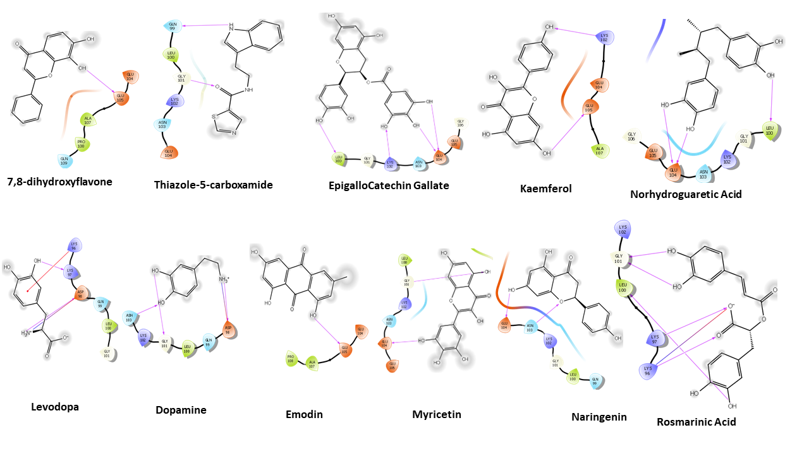
Fig. SI-3: Binding poses of standard compounds showing bonding and nonbonding interactions of the selected ligands with amino acid residues. Hydrogen bonding (magenta arrow), π - cation (red line), salt bridge (blue line) and π - π stacking (green line).

